Spectrum Estimation of Multimedia Signals

ECE 340 Lab D51
Riley Dixon - 1425251
Lab performed: November 24th, 2017

Analytic Solutions:
Lab4A Answers:
To find the various qualities of the audio file the built in command audioinfo() was used on our “love_mono22.wav” file. The requested qualities can be found in the table below:
Requested Quality | Value
File Size | 400kB
Sampling Rate | 22,050Hz
Duration | 18.141s
Number of Bits | 3,200,000
Bit Rate | 18.141 bits/sample

The magnitude spectrum plot curves downwards initially before it pleatues at 4kHz with a magnitude of about -35dB. The spectrum also has an upwards spike at 3kHz and a downwards spike at 2kHz. The most obvious feature of this spectrum however is how thick the graph appears as the magnitude greatly varies at the different frequencies.

The audio file has the most energy right at the beginning of the song when there is a loud “bang”. The energy then dwindles from this initial “bang” to about 4kHz with the exception of a burst of energy around the 3kHz mark. As the song progresses even further the power spectrum evens out at -30dB, which in turn also has the energy even out. It is during this last part where the annoying/tonal vocal part of the song takes place.
----------------------------------------------Lab4A-----------------------------------------
clear;
clc;

fileName = 'love_mono22.wav';
mono = audioread(fileName);
monoInfo = audioinfo(fileName);

%audioinfo partitioned into what we care about.
fileSize = monoInfo.TotalSamples;
samplingRate = monoInfo.SampleRate;
duration = monoInfo.Duration;
numOfBits = 8 * fileSize;
bitRate = fileSize/samplingRate;

fourierTransform = fft(mono);
%The positive frequencies are the first half.
positiveFT = fourierTransform(1:fileSize/2);
absScaledPositiveFT = abs(positiveFT./sqrt(fileSize/2));
frequency = linspace(1, samplingRate/2, length(positiveFT))/1000;

%Plot the magnitude spectrum
figure(1);
plot(frequency, 20*log10(absScaledPositiveFT));
title('Magnitude Spectrum');
xlabel('Frequency (kHz)');
ylabel('Magnitude of the FT of ''mono''');

[Px, F]=psd(mono, 512, samplingRate, [], 480);
figure(2);
plot(F/1000, 10.*log10(Px));
%Plots the power spectrum
%scaling F by 1000 will represent frequency in kHz
title('Power Spectrum');
xlabel('Frequency (kHz)');
ylabel('Power Spectral Density (in dB)');
----------------------------------------------Lab4A End-----------------------------------------

Q4 Answer:
Below is the Ayantika.tif image that will be analyised.

As easily noticed the image quality suffers from an artifact which appears to be a checkerboard superimposed on what should be considered the original image.

After running the provided Q4.m script the normalized range of both the horizontal and vertical axes was [-1, 1]. In addition the smaller peaks that represent the noise of the image are at the normalized locations: (0.52, 0), (-0.52, 0), (0, 0.52), and (0, -0.52).

----------------------------------------------Q4-----------------------------------------
clear
clc
% MATLAB code for spectral analysis and lowpass filtering of an image
% see section 17.6, Fig. 17.20, Fig. 17.21
%
% reading the image 'ayantika.tif'
I = imread('ayantika.tif');
imshow(I) % display the image
figure(2);
%fprintf('\nThe image Ayantika has been displayed')
%fprintf('\nPress any key to continue')
%pause
I = double(I);
I = I - mean(mean(I));
% 2D Bartlett window
x = bartlett(32);
for i = 1:32
zx(i,:) = x';
zy(:,i) = x ;
end
bartlett2D = zx .* zy;
mesh(bartlett2D) ;
%
n = 0;
% calculate power spectrum
P = zeros(256,256);
for (i = 1:16:320)
for (j = 1:16:288)
Isub = I(i:i+31,j:j+31).*bartlett2D;
P = P + fftshift(fft2(Isub,256,256));
n = n + 1;
end
end
Pabs = (abs(P)/n).^2;
mesh([-128:127]*2/256,[-128:127]*2/256,Pabs/max(max(Pabs)));
xlabel('Horizontal Frequency'); ylabel('Vertical Frequency');
zlabel('Power Spectrum (in dB)');
print -dtiff plot.tiff
----------------------------------------------Q4 End-----------------------------------------

Plots
The Magnitude Spectrum for love_mono22.wav
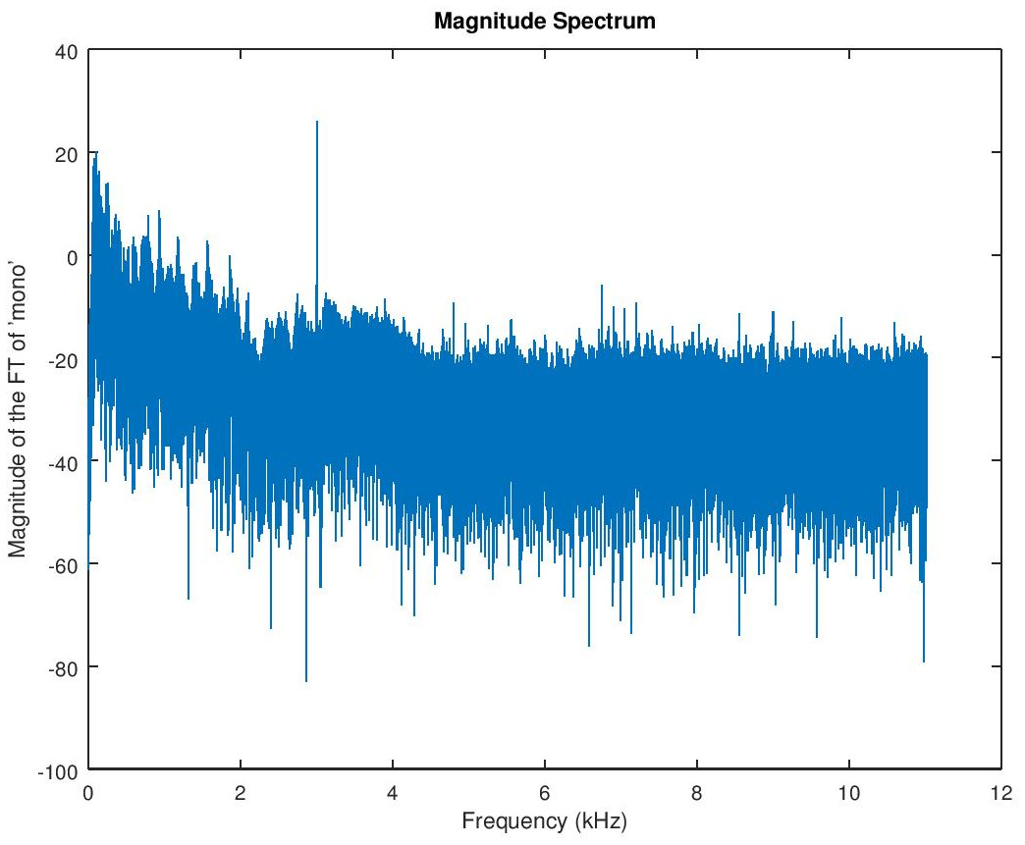
The Power Spectrum for love_mono22.wav
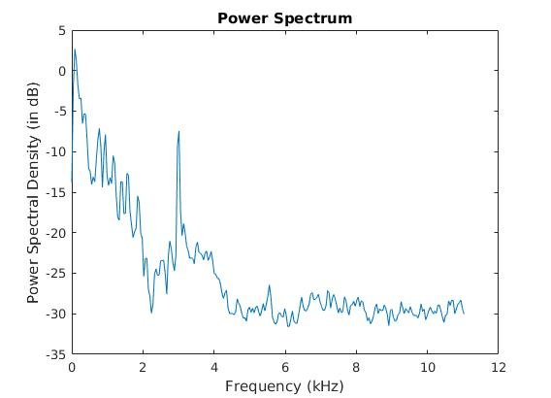

The 2D Fourier spectrum of ayantika.tif
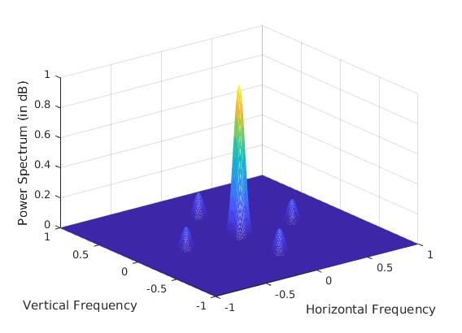
A top-down view of the 2D Fourier spectrum of ayantika.tif
